RETAIL CUSTOMER BEHAVIOR ANALYTICS DASHBOARD

End-to-End Data Analysis using Python, PostgreSQL & Power BI

By -
Rakshit Bansal
Aug 2026

Technologies Used
Python • Pandas • PostgreSQL • SQL • Power BI • Jupyter Notebook

Project Type
End-to-End Data Analytics Project

GitHub Repository
(Insert GitHub Repository Link Here)

EXECUTIVE SUMMARY
Modern retail organizations generate enormous amounts of transactional data through both online and offline customer purchases. While this information contains valuable insights into customer preferences and purchasing behaviour, it often remains underutilized without systematic analysis. Extracting meaningful patterns from such data enables businesses to make informed decisions related to customer engagement, inventory planning, promotional campaigns, and revenue optimization.
This project presents a complete customer behavior analytics pipeline developed using Python, PostgreSQL, and Power BI. Beginning with a raw retail transaction dataset, the project demonstrates the complete analytical workflow including data cleaning, preprocessing, exploratory data analysis, business-oriented SQL querying, and interactive dashboard development.
Python and the Pandas library were used to inspect the dataset, handle preprocessing tasks, engineer additional features such as customer age groups, and prepare the data for further analysis. PostgreSQL was then utilized to answer practical business questions through SQL, enabling deeper insights into customer spending patterns, subscription behaviour, product performance, seasonal trends, payment preferences, and customer satisfaction. Finally, an interactive Power BI dashboard was designed to present the most important performance indicators and business metrics in a visually intuitive format.
Rather than focusing only on visualization, the project emphasizes analytical thinking by translating business requirements into measurable Key Performance Indicators (KPIs) and SQL-based business questions. The final dashboard enables users to quickly evaluate customer demographics, purchasing behaviour, category-wise sales, revenue distribution, and customer subscription patterns.
Overall, this project demonstrates the complete lifecycle of a modern data analytics solution, integrating data preprocessing, structured querying, visualization, and business interpretation into a single workflow suitable for practical retail analytics applications.

1. INTRODUCTION
Data has become one of the most valuable assets for modern businesses. Every customer transaction contributes valuable information that can help organizations better understand customer preferences, evaluate business performance, and identify opportunities for growth. However, raw transactional data alone provides limited value unless it is transformed into actionable business insights through systematic analysis.
Retail organizations continuously collect information regarding customer demographics, purchase history, product categories, payment methods, shipping preferences, promotional offers, and customer feedback. Analyzing these variables collectively enables businesses to optimize pricing strategies, improve customer retention, enhance inventory planning, and personalize marketing campaigns.
The objective of this project is to demonstrate an end-to-end data analytics workflow using widely adopted industry tools. Starting from raw retail transaction data, the project performs data preprocessing using Python, executes analytical SQL queries within PostgreSQL, and finally presents business insights through an interactive Power BI dashboard.
Unlike traditional reports that only summarize numerical findings, this project emphasizes business-oriented analysis by answering practical questions that organizations commonly encounter during decision-making processes.
The completed solution provides an accessible and interactive platform for understanding customer behaviour, enabling business stakeholders to identify patterns and monitor key performance indicators efficiently.

2. BUSINESS PROBLEM
Retail businesses rely heavily on customer purchasing data to evaluate performance and formulate strategic decisions. Despite collecting large amounts of transactional information, organizations often struggle to derive meaningful insights due to fragmented datasets and limited analytical processes.
Several important business questions remain unanswered without structured analysis, including:
- Which customer segments contribute the highest revenue?
- Do loyalty or subscription programs influence customer spending?
- Which product categories generate the highest sales?
- How effective are promotional discounts?
- Which age groups contribute the most to overall revenue?
- Are repeat customers more likely to subscribe?
- Which payment methods are preferred by customers?
- How does customer satisfaction vary across product categories?
Answering these questions requires a systematic approach involving data cleaning, exploratory analysis, SQL-based querying, and dashboard visualization. This project addresses these challenges by transforming raw customer transaction data into meaningful business intelligence.

3. PROJECT OBJECTIVES
The primary objective of this project is to analyze retail customer purchasing behaviour and generate actionable business insights through an end-to-end analytics pipeline.
The specific objectives include:
- Perform data cleaning and preprocessing using Python and Pandas.
- Examine the dataset for inconsistencies, missing values, and data quality issues.
- Engineer additional analytical features to simplify business reporting.
- Conduct exploratory data analysis to understand customer demographics and purchasing trends.
- Develop SQL queries to answer business-oriented analytical questions.
- Measure customer spending behaviour across different demographic groups.
- Evaluate the impact of subscriptions, discounts, shipping methods, and seasonal purchasing patterns.
- Design an interactive Power BI dashboard for visualizing key business metrics.
- Present analytical findings in a structured and business-friendly format.
4. PROJECT ARCHITECTURE
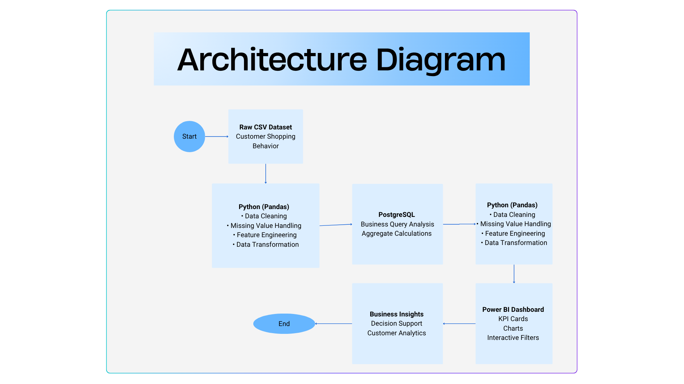

5. PROJECT WORKFLOW

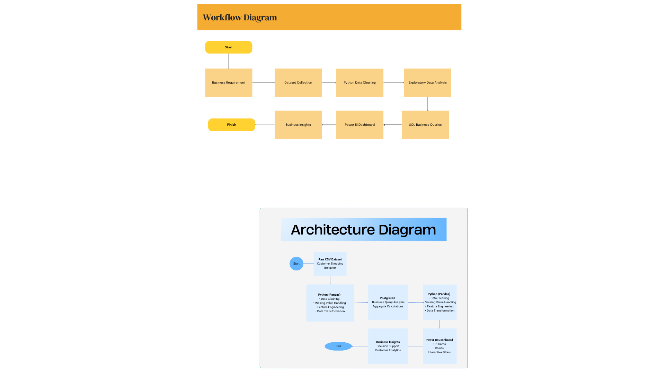
6. DATASET DESCRIPTION
6.1 Dataset Overview
The foundation of any analytical project lies in the quality and relevance of the dataset being analyzed. For this project, a retail customer shopping behavior dataset was used, containing transactional information collected from customer purchases across multiple product categories.
The dataset captures both demographic information and purchase-related attributes, enabling analysis from multiple business perspectives. Each record represents an individual customer transaction and includes variables associated with customer characteristics, purchasing decisions, shipping preferences, discounts, subscriptions, payment methods, and product reviews.
The diversity of features within the dataset makes it suitable for exploratory analysis, business intelligence reporting, and dashboard development.

Dataset Summary
Property | Details
Dataset Type | Retail Customer Transactions
File Format | CSV
Number of Records | Approximately 3900
Number of Features | 18
Tools Used | Python, PostgreSQL, Power BI
Domain | Retail Analytics

6.2 Dataset Attributes
The dataset consists of the following important variables:
Column | Description
Customer ID | Unique identifier assigned to every customer
Age | Customer's age
Gender | Male or Female
Item Purchased | Name of the purchased product
Category | Product category
Purchase Amount | Amount spent by the customer
Location | Customer location
Size | Product size
Color | Product color
Season | Season during which the purchase occurred
Review Rating | Customer rating for the purchased item
Subscription Status | Whether the customer has an active subscription
Shipping Type | Delivery option selected
Discount Applied | Indicates whether a discount was used
Promo Code Used | Whether a promotional code was applied
Previous Purchases | Number of earlier purchases made by the customer
Payment Method | Payment option used
Frequency of Purchases | Customer purchase frequency

6.3 Why This Dataset?
This dataset was selected because it combines demographic information with transactional and behavioral attributes, allowing multiple aspects of customer behavior to be explored within a single analysis.
Unlike datasets that focus only on sales, this dataset includes customer subscriptions, promotional offers, product ratings, shipping methods, and historical purchasing activity. These additional variables make it possible to answer business-oriented questions that closely resemble real-world retail analytics scenarios.

7. TECHNOLOGY STACK
A combination of programming, database, and visualization tools was used to complete the project. Each technology served a specific purpose within the analytics workflow.
Technology | Purpose
Python | Data preprocessing and analysis
Pandas | Data manipulation and cleaning
PostgreSQL | Business query execution
SQL | Analytical query writing
Power BI | Dashboard development
Jupyter Notebook | Interactive development environment

8. DATA PREPARATION AND CLEANING
Before performing any analytical operations, the dataset was carefully examined to ensure data quality and consistency. Proper preprocessing is essential because inaccurate or incomplete data can significantly affect analytical outcomes.
The preprocessing stage was performed entirely using Python and the Pandas library within Jupyter Notebook.
The following workflow was followed.

Step 1: Importing Required Libraries
The analysis began by importing the required Python libraries.
Primary libraries included:
- Pandas
- NumPy (if used)
- Matplotlib (if used)
- Seaborn (if used)
These libraries provide functionality for data loading, preprocessing, statistical analysis, and visualization.
Figure 8.1:
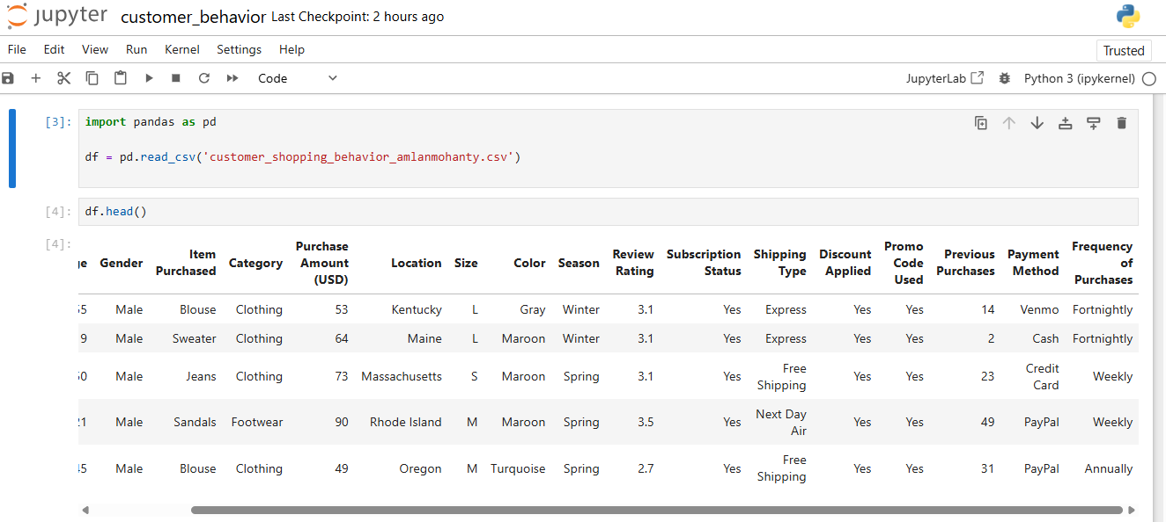

Step 2: Loading the Dataset
The CSV dataset was imported into a Pandas DataFrame for analysis.
After loading, the first few records were inspected to verify successful import and understand the dataset structure.
The following inspections were performed:
- Previewing initial records
- Checking total rows and columns
- Understanding feature names

Step 3: Understanding the Dataset
To understand the structure of the dataset, descriptive information was generated using built-in Pandas functions.
The following properties were examined:
- Number of rows
- Number of columns
- Data types
- Memory usage
- Presence of missing values
This preliminary inspection helped identify potential preprocessing requirements before further analysis.
Figure 8.3:
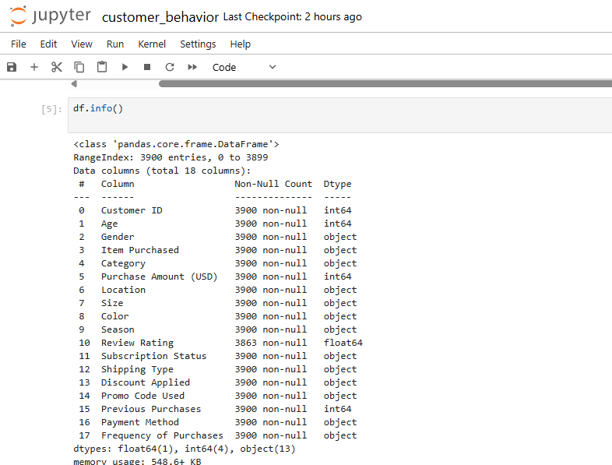

Step 4: Missing Value Analysis
One of the first preprocessing tasks involved checking the dataset for incomplete or missing values.
Missing values can introduce bias into analytical results and therefore must be identified before conducting statistical analysis.
Each column was examined individually to determine whether any missing observations existed.
Where required, suitable preprocessing techniques were applied to ensure data consistency.
Figure 8.3:
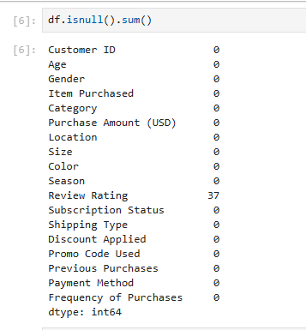

Step 5: Data Cleaning
After identifying inconsistencies, the dataset underwent cleaning to improve its quality.
The cleaning process included:
- Handling missing values
- Verifying numerical columns
- Standardizing categorical entries
- Removing unnecessary inconsistencies
- Preparing the dataset for SQL analysis
These operations ensured that subsequent analysis was performed on reliable and consistent data.

9. FEATURE ENGINEERING
Raw datasets often require additional features that simplify business reporting.
Instead of repeatedly writing complex SQL conditions, new analytical variables were generated during preprocessing.
One such feature created during this project was Age Group.
Customers were categorized into meaningful demographic groups, allowing revenue and purchasing behavior to be analyzed more effectively across age segments.
The generated age groups included categories such as:
- Teen
- Young Adult
- Adult
- Senior
This transformation simplified both SQL queries and Power BI visualizations while improving the interpretability of analytical results.
Figure 9.1: creation of the age_group column
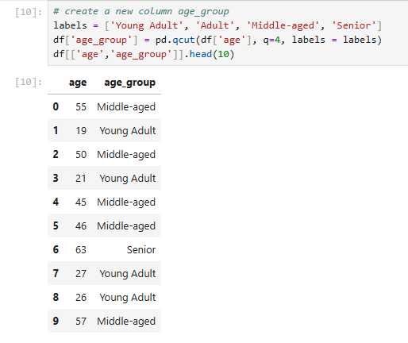

10. EXPLORATORY DATA ANALYSIS
Once preprocessing was completed, exploratory data analysis (EDA) was performed to gain an initial understanding of customer behavior.
EDA focuses on summarizing important characteristics of the dataset before applying advanced analytical techniques.
The analysis aimed to answer questions such as:
- How are customers distributed across different age groups?
- Which product categories appear most frequently?
- How are purchase amounts distributed?
- What is the distribution of customer ratings?
- Are subscribed customers common?
- Which payment methods are frequently used?
Rather than drawing final conclusions, exploratory analysis serves as the foundation for identifying trends that can later be validated using SQL queries and dashboard visualizations.

Initial Observations
The exploratory analysis indicated that customer purchases were distributed across multiple product categories with relatively balanced representation.
Purchase amounts varied considerably among customers, suggesting the presence of both low-value and high-value transactions.
Customer ratings generally remained within the higher end of the rating scale, indicating positive overall customer satisfaction.
Subscription status, discount usage, shipping preferences, and purchase frequency displayed sufficient variation to support meaningful business analysis in later stages of the project.

11. SQL-BASED BUSINESS ANALYSIS
Following data preprocessing, the cleaned dataset was imported into PostgreSQL for business analysis. SQL was used to answer practical questions that retail organizations commonly encounter while evaluating customer behaviour and sales performance.
The analysis focuses on customer demographics, purchasing behaviour, subscriptions, discounts, product performance, and revenue contribution. Each query was designed to address a specific business objective rather than simply retrieve data.

Query 1: Revenue Generated by Male vs Female Customers
Business Objective
To compare the total revenue generated by male and female customers and understand purchasing behaviour across customer demographics.
SQL Approach
The dataset was grouped by gender, and the purchase amount was aggregated using the SUM() function.
Figure 11.1: SQL query and output screenshot
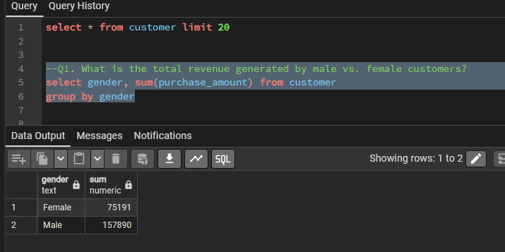
Business Interpretation
This analysis provides an overview of revenue contribution by gender. Such information can help retailers evaluate whether customer engagement or promotional strategies differ across demographic groups and whether targeted marketing initiatives may be beneficial.

Query 2: High-Value Customers Purchasing with Discounts
Business Objective
Identify customers who received discounts but still spent more than the overall average purchase amount.
SQL Approach
A subquery was used to calculate the average purchase amount. Customers with applied discounts whose purchases exceeded this average were then filtered.
Figure 11.2:
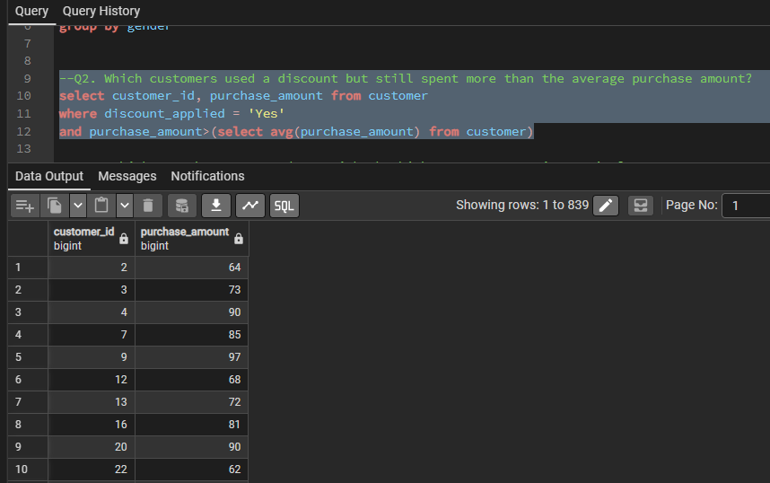
Business Interpretation
Contrary to the assumption that discounts primarily attract low-value purchases, this analysis identifies premium customers who also utilize promotional offers. This insight helps businesses evaluate the effectiveness of discount campaigns across different customer segments.

Query 3: Highest Rated Products
Business Objective
Determine which products consistently receive the highest customer satisfaction ratings.
SQL Approach
Products were grouped by item name, and their average review rating was calculated before selecting the top five.
Figure 11.3:
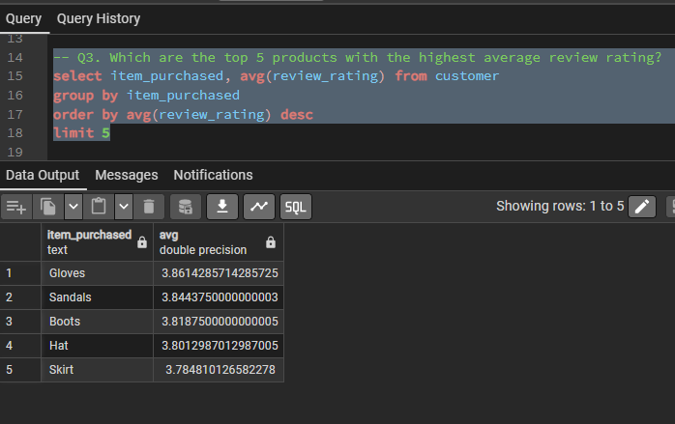
Business Interpretation
Highly rated products indicate strong customer satisfaction and can guide inventory planning, premium marketing campaigns, and future product recommendations.

Query 4: Standard vs Express Shipping Analysis
Business Objective
Compare customer spending between Standard and Express shipping options.
SQL Approach
Average purchase amounts were calculated separately for Standard and Express shipping methods.
Figure 11.4:
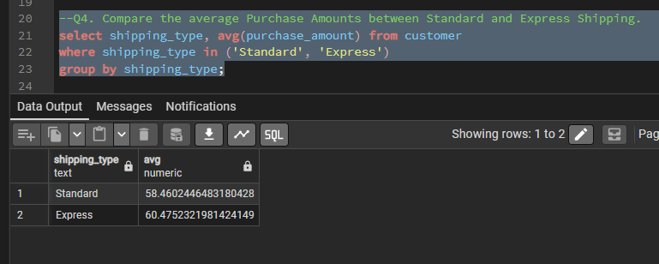
Business Interpretation
Understanding whether customers selecting faster shipping also spend more helps retailers optimize delivery strategies and premium shipping offerings.

Query 5: Subscription Impact on Customer Spending
Business Objective
Evaluate whether subscribed customers contribute greater revenue than non-subscribed customers.
SQL Approach
Customer counts, average purchase amounts, and total revenue were calculated for subscribed and non-subscribed customers.
Figure 11.5:
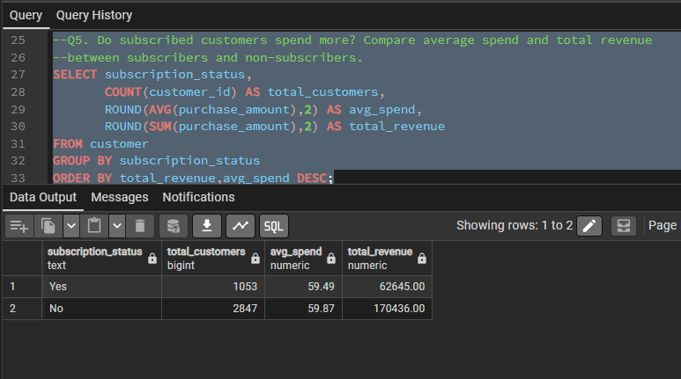
Business Interpretation
Subscription programs often represent customer loyalty. Comparing spending behaviour between these groups provides valuable insights into the effectiveness of subscription-based engagement strategies.

Query 6: Products Most Frequently Purchased with Discounts
Business Objective
Identify which products are most commonly purchased using discounts.
SQL Approach
The percentage of discounted purchases was calculated for each product using conditional aggregation.
Figure 11.6:
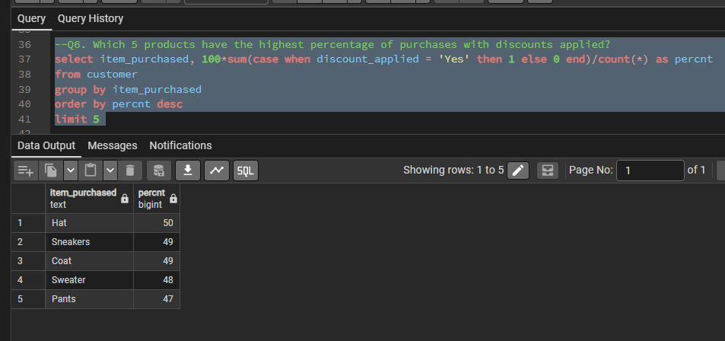
Business Interpretation
This analysis highlights products that rely heavily on promotional pricing, helping businesses evaluate discount dependency and pricing strategies.

Query 7: Subscription Behaviour Among Repeat Customers
Business Objective
Determine whether customers with a strong purchasing history are more likely to subscribe.
SQL Approach
Customers having more than five previous purchases were filtered and grouped by subscription status.
Figure 11.7:
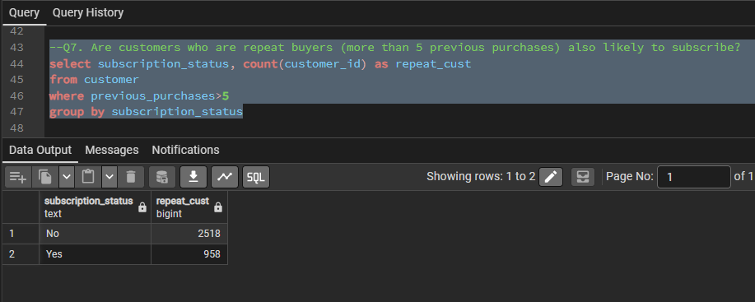
Business Interpretation
Repeat customers are valuable assets for any business. Understanding their subscription behaviour helps measure customer loyalty and retention.

Query 8: Revenue Contribution by Age Group
Business Objective
Analyze which customer age groups generate the highest overall revenue.
SQL Approach
Using the engineered age_group feature, purchase amounts were aggregated for each demographic segment.
Figure 11.8:
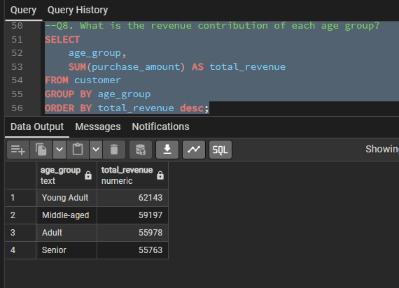
Business Interpretation
Revenue distribution across age groups enables businesses to identify their most valuable customer segments and tailor marketing campaigns accordingly.

Query 9: Revenue by Payment Method
Business Objective
Determine customer payment preferences and evaluate revenue generated through different payment methods.
SQL Approach
Orders, total revenue, and average purchase amounts were grouped by payment method.
Figure 11.9:
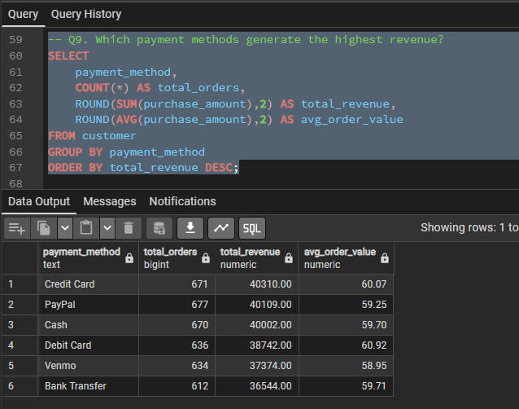
Business Interpretation
Understanding preferred payment methods assists retailers in optimizing payment partnerships, improving checkout experiences, and introducing targeted promotional offers.

Query 10: Seasonal Sales Analysis
Business Objective
Identify seasonal trends in customer purchasing behaviour.
SQL Approach
Orders and revenue were aggregated according to season.
Figure 11.10:
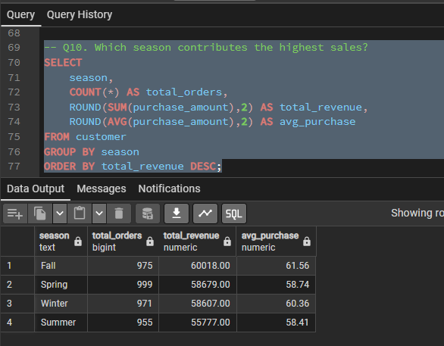
Business Interpretation
Seasonal demand analysis supports inventory planning, promotional scheduling, and workforce allocation throughout the year.

12. POWER BI DASHBOARD
After completing the SQL-based analysis, the findings were consolidated into an interactive dashboard developed using Microsoft Power BI. The objective of the dashboard was to provide business stakeholders with a concise overview of customer behaviour through intuitive visualizations and key performance indicators.
The dashboard was designed with a clean layout, allowing users to quickly identify revenue trends, customer distribution, purchasing behaviour, and category-wise performance. Rather than displaying raw data, the dashboard emphasizes actionable insights that support business decision-making.
Figure 12.1:
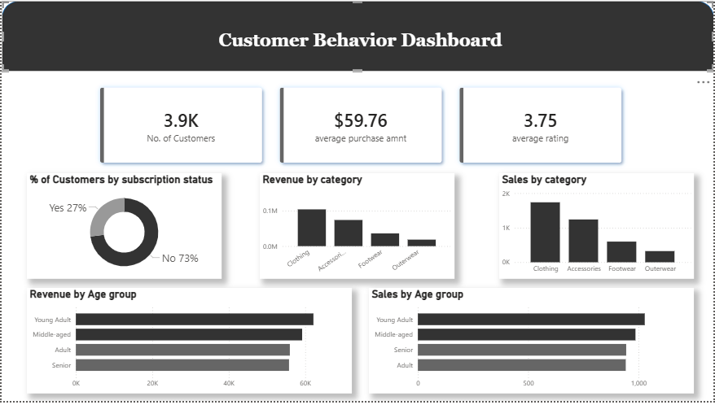
Dashboard Components
The dashboard consists of the following key elements:
- KPI Cards: Display total customers, average purchase amount, and average review rating to provide a quick summary of business performance.
- Revenue by Category: Highlights the contribution of each product category to total revenue, enabling easy identification of high-performing categories.
- Customer Distribution: Visualizes customer demographics based on gender and subscription status.
- Revenue by Age Group: Illustrates which demographic segments contribute most significantly to sales.
- Category-wise Sales: Compares sales across product categories to identify purchasing trends.
The dashboard transforms analytical findings into an interactive business intelligence solution, enabling stakeholders to explore data from multiple perspectives without requiring technical expertise.
13. KEY BUSINESS INSIGHTS
The analysis produced several meaningful observations regarding customer purchasing behaviour and retail performance:
- Customer spending patterns vary across demographic groups, indicating opportunities for more targeted marketing strategies.
- Subscription programs appear to influence purchasing behaviour and contribute significantly to overall business revenue.
- Several customers continue to make high-value purchases even when promotional discounts are available, suggesting that discounts are not exclusively used by low-spending customers.
- Revenue is concentrated within a limited number of product categories, highlighting areas of strong customer demand.
- Customer satisfaction remains consistently high across many products, indicating positive overall shopping experiences.
- Seasonal trends suggest opportunities for optimizing inventory planning and promotional campaigns.
- Repeat customers demonstrate characteristics associated with long-term customer loyalty, emphasizing the importance of customer retention initiatives.

14. LEARNING OUTCOMES
This project provided valuable practical experience in applying the complete data analytics lifecycle to a real-world retail dataset. Through the project, I strengthened my understanding of data preprocessing, exploratory analysis, SQL-based business querying, and interactive dashboard development.
Working with Python and Pandas improved my ability to clean and transform raw datasets into analysis-ready formats. Using PostgreSQL reinforced my SQL skills by translating business requirements into structured queries that generated meaningful insights. Designing the Power BI dashboard enhanced my understanding of data visualization principles and effective communication of analytical findings.
Beyond technical skills, the project emphasized the importance of framing analytical work around business questions rather than focusing solely on tools or code. This experience strengthened my ability to connect technical analysis with practical business decision-making.

15. CONCLUSION
This project demonstrates a complete end-to-end customer analytics workflow using Python, PostgreSQL, and Power BI. Starting from raw transactional data, the project progressed through data cleaning, exploratory analysis, SQL-driven business intelligence, and dashboard visualization to produce actionable insights into customer purchasing behaviour.
By integrating multiple technologies within a single analytical pipeline, the project illustrates how raw retail data can be transformed into meaningful information that supports strategic decision-making. The resulting dashboard provides stakeholders with an accessible platform for monitoring customer demographics, purchasing trends, subscription behaviour, and product performance.

